 | 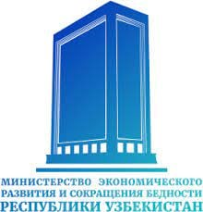 | 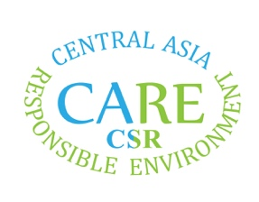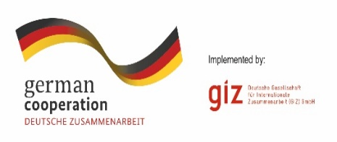

INTERNATIONAL CONFERENCE 2022
“CSR AND ESG IN EMERGING MARKETS”

CO-ORGANIZERS:
- MINISTRY OF ECONOMIC DEVELOPMENT AND POVERTY REDUCTION
- CARE CSR LTD.
- GERMAN DEVELOPMENT COOPERATION AGENCY (GIZ)
DATE: November 29, 2022
TIME: 10:00AM (registration at 9:30AM)
ZOOM link: https://mdis.zoom.us/j/83506737564?pwd=T1Z6OVhzanQrcG1CK3J0T212MWh5UT09
MEETING ID: 835 0673 7564
PASSCODE: mdist
INTERNATIONAL CONFERENCE 2022
“CSR AND ESG IN EMERGING MARKETS”
MODERATORS

MALIKA SHARIPOVA – Leading Expert, Founder of CARE CSR Ltd.
YULIYA PARAMONOVA - Senior Lecturer, School of Business and Management, MDIS Tashkent

9:30 – 10:00 | Registration of guests
10:00 – 10:10 | Opening speech  DR. JASUR SALIKHOV  Rector, Management Development Institute of Singapore in Tashkent
10:10 – 10:20 | Welcome speech  ILHOM NORKULOV  First Deputy Minister  Ministry of Economic Development and Poverty Reduction of the Republic of Uzbekistan
10:20 – 10:30 | Welcome speech  ODILBEK ISAKOV  Deputy minister  Ministry of Finance of the Republic of Uzbekistan
10:30 – 10:40 | Welcome speech  OYDIN SATTOROV  Project manager, Global Programme ‘Sustainability and Value Added in Agricultural Supply Chains’  German Development Cooperation Agency (GIZ)
SESSION ON ENTREPRENEURSHIP AND SUSTAINABILITY

10:40 – 10:55 | JOSEPH KAPP (ONLINE)  Entrepreneur in Residence at Eastern WV Community & Technical College and CEO at Behavioral Business, LLC  “Entrepreneurship & Climate Change”
10:55 – 11:10 | XAKIMOV JAVLONBEK  Deputy Director, Green Economy Development Department, Ministry of Economic development and poverty reduction  “Government framework on ESG implementation support”
11:10– 11:25 | ATAUR BELAL (ONLINE)  Professor of Accounting and Sustainability  University of Birmingham, United Kingdom  “SDG implementation in fashion, textiles and manufacturing”
11:25 – 11:40 | PROF. KANA SUKUMARAN  Dean, Academic Affairs, MDIS Tashkent  “CSR and Development Issues in Uzbekistan - an Exploration”
11:40– 12:10 | COFFEE BREAK
SESSION ON ROLE OF ESG/CSR IN INVESTMENT

12:10 – 12:25 | TOBY USNIK (ONLINE)  Head of Communications at British Consulate General NY  “Environmental, Social, Governance (ESG): Why You Should Care”
12:25– 12:40 | ASKAR OBIDOV  Director Ernst & Young (E&Y)  "The Role of ESG in Ensuring Financial Stability and Attracting Investments"
12:40 – 12:55 | DENIS TORKHOV  EBRD Advice for Small Businesses in Uzbekistan  “Support in implementation of green technologies in SMEs”
12:55 – 13:10 | MICHAEL MATESIC  CEO, Idea foundry USA  "More than a trillion dollars are waiting for you”
13:10 – 13:25 | ASKAR KARIMOV  CEO, Breadly Bakery  “How responsible business can look like?”
SESSION ON SUSTAINABLE TOURISM
13:25 – 13:40 | AZIZ ABDULLAYEV  "SHAROIT PLUS" public association of people with disabilities  “Benefits of inclusivity for companies”
13:40 – 13:55 | YAKUBOVA SHAMSHINUR SHUXRATOVNA  Head of Turizm and Marketing Department  Karshi State University  “Implementation of ESG in Uzbekistan: current realities and new priorities”
13:55 – 14:10 | SHAKHNOZAKHON FAKHRIDDINOVA  Lecturer of Tourism and Hospitality School, MDIS Tashkent  “Sayohat barcha uchun”
14:10 – 14:25 | DR MIR ABDUL SOFIQUE (ONLINE)  Associate Professor, The University of Burdwan  “Rural tourism and traditional handicraft making- with special reference to Natungram, West Bengal”
CLOSING CEREMONY
14:25-14:40 | DR. JASUR SALIKHOV  Rector, Management Development Institute of Singapore in Tashkent  MALIKA SHARIPOVA  CSR/ESG expert  Founder CARE CSR LLC

